WARNING: The descriptions of typical flying conditions listed in this site guide reflect the experience of the authors of the guide. The conditions that you encounter at the site may differ, sometimes substantially, from those encountered by the authors. The descriptions of their experiences may not be relevant to the likely experience of any other pilot, particularly one who is relatively inexperienced or new to the site. A decision to launch is always that of the individual pilot. When deciding whether or not to fly, a pilot may wish to take into account the descriptions in this site guide but must also consider numerous other factors including the pilot's training and experience, familiarity with the site, equipment, physical and mental condition and the specific conditions in existence at the time of the decision. Always ​fly within the USHPA recommended operating limitations for your rating as specified in the USHPA Pilot Proficiency System. Pilots of relatively little experience or who are new to the site are urged to consult with other local pilots at the site in order to obtain their assessment of the conditions. ​Always get a site briefing from a local pilot. Do not fly sites alone or without a local pilot present. If locals are not flying, there is likely a reason.

ALL PILOTS SHOULD FAMILIARIZE THEMSELVES WITH USHPA’S SAFETY PROCEDURES BEFORE FLIGHT

Sandia Soaring Association Site Guide
The SSA insures, maintains, and regulates several flying sites in the Central New Mexico area. Many Sites are considered sensitive and flying at our sites requires adhering to specific procedures.
The rating listed for a given launch or landing zone does not mean that if you have that rating you will necessarily be able to safely launch or safely land. The rating means you should have knowledge at that level to decide whether it is safe for you to launch or land in the existing conditions.
Always ​Fly within the recommended operating limitations for your rating; pay attention to changing conditions and weather forecasts. Flying into mid day and peak heating conditions should be reserved for Advanced pilots. Reference USHPA recommended operating limitations for your rating in the USHPA USHPA Pilot Proficiency System.
Cross-country flights from all of our sites fly over National Forest, Tribal Lands, private property, State Park land and controlled airspace. You should familiarize yourself with the locations of legal landing zones and strict no landing areas before venturing XC. Power assisted flight is non recommended or prohibited at most of our foot launch soaring sites due to conditions and/ or use agreements.

Sandia Peak (Peak Launch)
“Ensure you read the entire site guide”
In order to fly this site you must be a USHPA and SSA Member

Location: 35.196576°, -106.434662° Just north of the Top Terminal of Sandia Peak Tramway

Description: Sandia Peak and the Peak Launch is the premier flying site in New Mexico. It is a high altitude, Tram accessed site that is home to numerous 100 mile flights and has been the site of the HG World Championships. Evening glass offs while surfing the massive granite walls is a truly amazing experience.

Based on the complexity and difficultly of the launch, combined with the dry, booming, desert thermals this is not a casual flying site. Our mountain is a rock that sticks up 5000ft in the middle of high desert. Wind, changing weather conditions, massive overdevelopment, and eye popping climbs are not out of the ordinary.
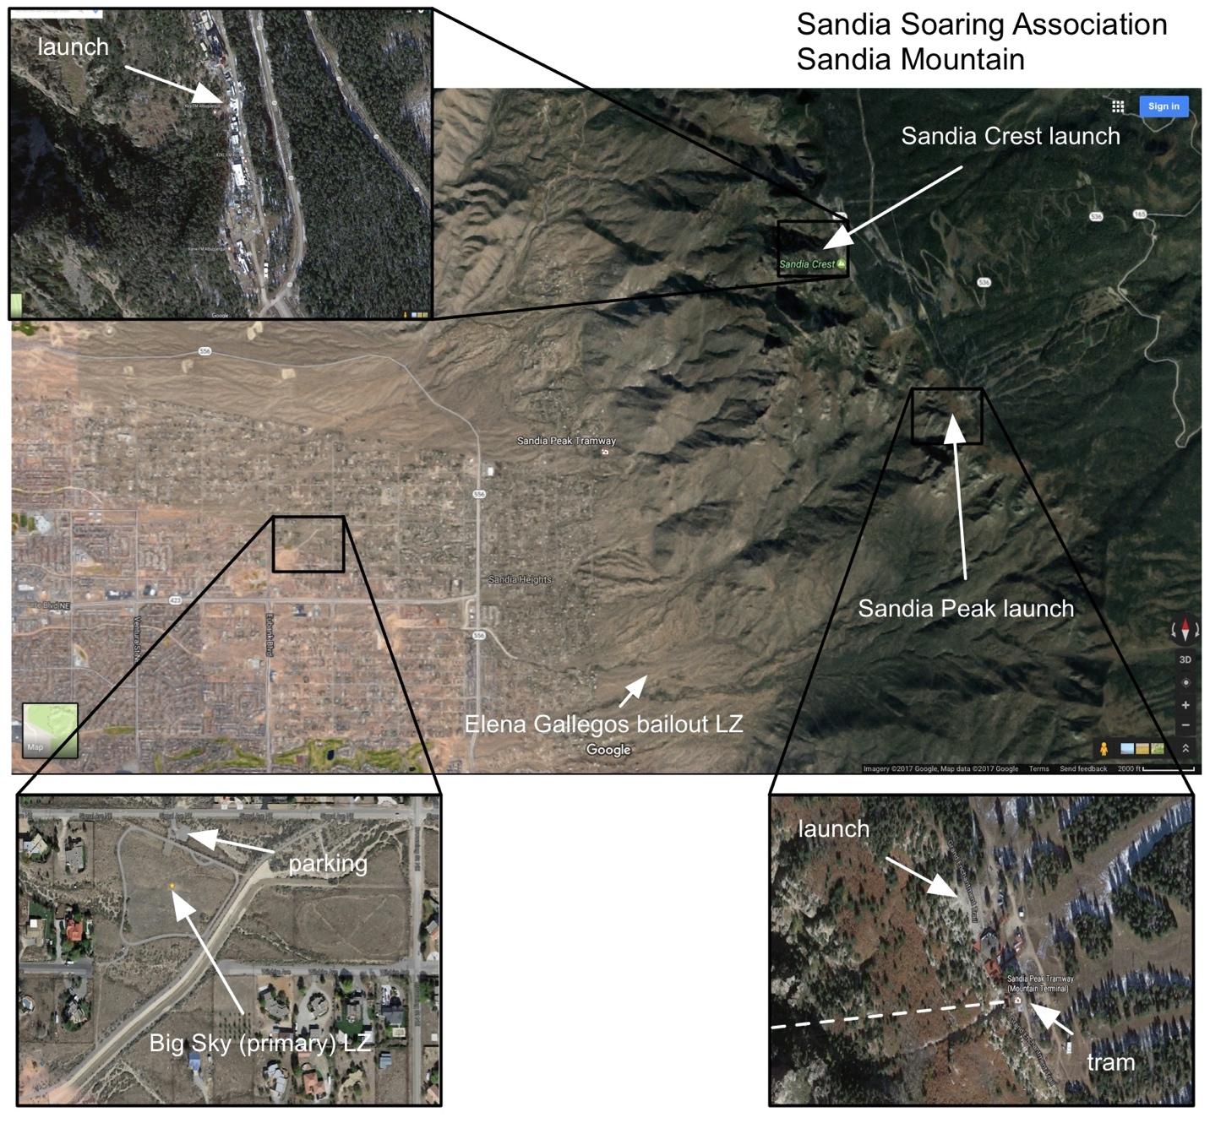

General Information:
- Current USHPA and SSA Membership required (Annual or Visiting).
- Visiting Pilots/ Temporary Members must have a site introduction with a local Full P4/H4 SSA member for access and site briefing (see below).
- Minimum Ratings: H4 / P4 and the CL, FL, TUR and HA special skills. HGs also need RLF.
- Pilots should have mountain flying experience
- Local P3/H3 Exemption: Full membership local SSA pilots meeting the following requirements can fly the peak when accompanied by current peak rated pilot: 150 flights, 5 different inland sites, 50 days, 45 hours, with 25 in thermal lift, CL, FL, TUR, and HA special skills, and RLF for Hangs. Proof of meeting these requirements needs to be submitted, along with 3 letters of recommendation from peak rated pilots, to the club President for P3/H3 Exemption Card issuance.
- Mini Wing are currently being evaluated for this site.
- Tandems must comply with USHPA SOP 12-12 Tandem program and Federal Aviation Administration Tandem exemption #4721. Commercial Tandems must apply for and hold a separate permit with the Forest Service and obtain permission from the Sandia Peak Tramway.
- Always ​fly within the USHPA recommended operating limitations for your rating as specified in the USHPA Pilot Proficiency System.
- Best conditions: 5-10 mph SSW, SW, W
- Best time(s) of day to fly: Afternoon through evening glass off. Mid Day Flying can be turbulent and requires advanced piloting skills.
- Most flyable season(s): Fall is the classically good season. Winter can be flyable but snow and ice may prevent safe launching and most days are northerly in Winter. The Biggest XC days come in Spring and Early Summer but flying can be very strong, turbulent and windy. Summer is prone to OD because of the Monsoon Season. Very few days are flyable July- Mid August.
- The primary LZ is a city park field (Sen. Harrison H. Schmitt Big Sky Hang Glider Park (35.18265, -106.51897, 5800 ft), known simply as “Big Sky”) that is dedicated to the activity. Many hang gliders consider it a bit small. Pilots should leave the bottom of the Tram area with a minimum of 8500ft to make the Big Sky LZ.
- A very large and grassy secondary LZ is available at the Balloon Fiesta park (35.19650, -106.59695, 5055 ft). Check for closures before going there (like during the Balloon Festival SEP-OCT) and watch for pedestrian uses of the fields.
- Should pilots not make Big Sky or desire to do so, landing is possible at the Elena Gallegos “bailout” LZ (35.16654, -106.47386, 6400 ft). This landing is in rolling desert terrain with many small bushes and trees and is not maintained. Only land there if you are comfortable outlanding in rough terrain and in potentially turbulent conditions.
- Peak Launch altitude: 10,275 feet
- Big Sky Landing zone altitude: 5,790 feet
- Distance Main Launch to Big Sky LZ: 4.83 miles
- Straight glide Launch to Main LZ: 5.7
- Launch access: Via Sandia Peak Tramway (see below for special instructions)
- All pilots are required to fly with a functioning radio tuned to 151.925 MHz in order to monitor for any need to clear airspace.
- Flight schools or instructors may not have a physical business presence or set-up a concession operation on site. Site access has been granted for casual recreational use only.
Access and First Time Pilots:
Sandia Peak (Peak Launch) is accessed via the Sandia Peak Tramway. Pilots must purchase a Tram ticket, sign in, show proof of a current USHPA P4/H4 membership, and be on the current SSA roster for full or temporary membership. First time pilots to the Peak must be accompanied by a Full SSA Member with a P4/H4 rating. They will be given a site introduction to include Tram protocols, launch, landing and flying hazards. This is not a guided flight and the pilot must make their own decisions to launch, land and where and when to fly.
Launching:
The Peak launch was recently renovated and one of the best sites in the state. The surface of the launch is smooth and free of snags. There is room for multiple gliders to set up and prepare in the back but launching one at a time is recommended.
The preferred wind direction is west to southwest. South wind can be very tricky and should be avoided by first time pilots. North and North west are not recommended.
All normal launch techniques will work, but pilots should be aware that they are launching at the top of a 5000ft mountain in the desert. Our launch is just above a cliff face and it is possible that the wind you feel standing on launch is considerably lighter than the wind 10-15ft over your head. Use the tall trees to your north as guide for winds overhead.

Sandia Peak (Crest Launch)
“Ensure you read the entire site guide”
In order to fly this site you must be a USHPA and SSA Member

Location: 35.21342, -106.45026, 10 600 ft) is accessed using a public road to the mountain top and the launch is inside a gated communication tower area (contact the club for access).
General Information:
- Current USHPA and SSA Membership required (Annual or Visiting).
- Visiting Pilots/ Temporary Members must have a site introduction with a local Full P4/H4 SSA member for access and site briefing (see below).
Minimum Ratings: P4 H4 and the CL, FL, TUR and HA special skills. HGs also need RLF. Local SSA members with an H3 rating and instructor present OR with an H3 rating, 50 logged flight hours, mountain flying experience, and restricted landing field special skill. Pilots should have mountain flying experience
- Local P3/H3 Exemption: Full membership local SSA pilots meeting the following requirements can fly the peak when accompanied by current peak rated pilot: 150 flights, 5 different inland sites, 50 days, 45 hours, with 25 in thermal lift, CL, FL, TUR, and HA special skills, and RLF for Hangs. Proof of meeting these requirements needs to be submitted, along with 3 letters of recommendation from peak rated pilots, to the club President for P3/H3 Exemption Card issuance.
- Mini Wing are currently being evaluated for this site.
- Tandems must comply with USHPA SOP 12-12 Tandem program and Federal Aviation Administration Tandem exemption #4721. Commercial Tandems must apply for and hold a separate permit with the Forest .

- Always ​fly within the USHPA recommended operating limitations for your rating as specified in the USHPA Pilot Proficiency System.
- Best conditions: 5-10 mph W, NW
- Best time(s) of day to fly: Afternoon through evening glass off. Mid Day Flying can be turbulent and requires advanced piloting skills.
- Most flyable season(s): Fall is the classically good season. Winter can be flyable but snow and ice may prevent safe launching and most days are northerly in Winter. The Biggest XC days come in Spring and Early Summer but flying can be very strong, turbulent and windy. Summer is prone to OD because of the Monsoon Season. Very few days are flyable July- Mid August.
- The primary LZ is a city park field (Sen. Harrison H. Schmitt Big Sky Hang Glider Park (35.18265, -106.51897, 5800 ft), known simply as “Big Sky”) that is dedicated to the activity. Many hang gliders consider it a bit small. Pilots should leave the bottom of the Tram area with a minimum of 8500ft to make the Big Sky LZ.
- A very large and grassy secondary LZ is available at the Balloon Fiesta park (35.19650, -106.59695, 5055 ft). Check for closures before going there (like during the Balloon Festival SEP-OCT) and watch for pedestrian uses of the fields.
- Should pilots not make Big Sky or desire to do so, landing is possible at the Elena Gallegos “bailout” LZ (35.16654, -106.47386, 6400 ft). This landing is in rolling desert terrain with many small bushes and trees and is not maintained. Only land there if you are comfortable outlanding in rough terrain and in potentially turbulent conditions.
- Crest Launch altitude: 10,600 feet
- Big Sky Landing zone altitude: 5,790 feet
- Distance Main Launch to Big Sky LZ: 4.4 miles
- Straight glide Launch to Main LZ: 5.7
- Launch access: Via Highway 536 See below for special instructions
- All pilots are required to fly with a functioning radio tuned to 151.925 MHz in order to monitor for any need to clear airspace.

Launching: Ideal launch conditions for at the crest are light winds (<10MPH) and general west flow. The crest launch is situated in a west facing bowl where NW and SW winds may 'wrap' in.
- In stronger winds, significant rotor may be present in the launch bowl, primarily from the South Pinnacle, which is a prominent feature WSW of launch.

Flying:
As a P4/H4 pilot with mountain experience you are expected to make sound decisions within your experience and comfort level. Here are some site specific considerations to take into account:
1. When north of the Tram, getting below the level of the Tram cables between launch and tower 2 can often result in severe turbulence, rotor, and being flushed into an unlandable zone. This is especially true with West, NW and North Winds. Check the wind sock direction at the Tram tower 2. If it’s WNW – North, then beware of flying.
2. SSW, SW and West winds are preferred for the Peak Launch . West winds can make for great flying but be aware of rotor coming off the Tower 2 ridge. In NW and North expect severe turbulence and rotor.
3. West or slight northwest are preferred for the Crest Launch.
4. Mid day flying in Spring, Summer and early Fall can be quite strong with climbs 1900fpm (10m/s) common during mid day.
4. The West side of the Sandias are composed of large granite cliffs that have many ridges and peaks. When flying near terrain and in these ridges and peaks you should be very aware of meteo wind direction and the potential to fly into rotor.
6. Wonderful XC potential exists when flying from Sandia Peak. The classic routes involve flying East towards Santa Rosa or North towards Santa Fe. If flying XC you will likely need to make the move to fly “over the back” and head east. 3000ft AGL over the top of the mountain (13,500ft) is recommended to avoid the flush and potential rotor when crossing over the back.
7. AIRSPACE: As seen below, Albuquerque is nearly entirely covered by Class C Airspace.
On approach to the LZ be aware of Airspace. The portion located at the LZ has a floor of 6900ft and a ceiling of 9400ft.
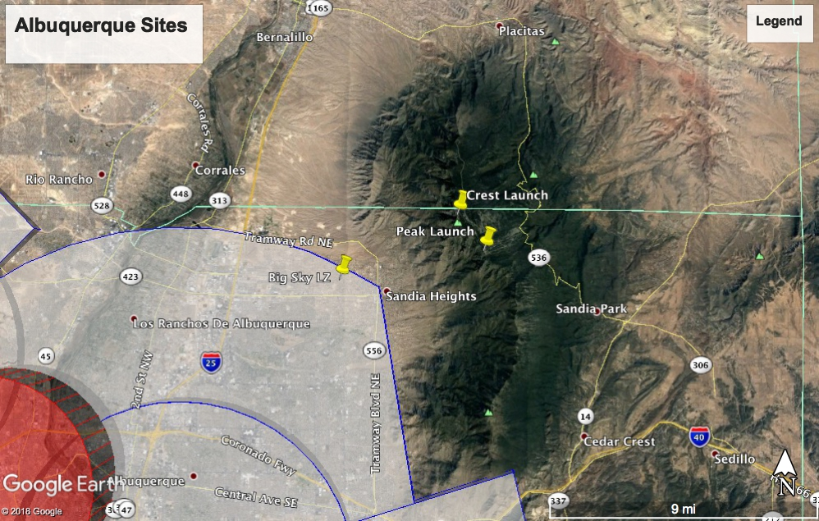

Landing:
This section will deal primarily with the Big Sky LZ.
When leaving the mountain you will have to over fly a few miles of residential housing before arriving at the LZ. It is recommended that you leave the base of the mountain with at least 8500ft of altitude in light to medium wind conditions. Strong West winds require much higher departure altitude to make the LZ. The Elena Bailout LZ is noted above. There are also many residential lots on the way to the LZ that do not have structures on them. Be aware that many are bordered by power lines and contain large amounts of cactus.
The LZ has a large windsock located in the south west corner of the field. It is surrounded by an asphalt walking path and a low fence. To the immediate east of the LZ is a ditch and additional open space . Be aware of a slight east to west downhill slope in the LZ.
Most of the time you will be landing towards the south or west as those are the dominate flyable wind directions. Be aware of late evening east katabatic flows coming off the mountain.
For paragliders a standard figure 8 landing approach setting up over the houses to the north on a south wind landing or a figure 8 approach setting up in the open space east of the field tends to work the best.
For HG It is highly recommended to walk the Big Sky LZ prior to landing there. The most common HG approach is due South. You set up your approach on the North side of the landing field, lose altitude and land to the South. North approaches are also recommended however there’s a power-line running E-W on the far North side of the LZ. East approaches are simple and straightforward. West approaches can be difficult for high performance HG due to the slope of the field
